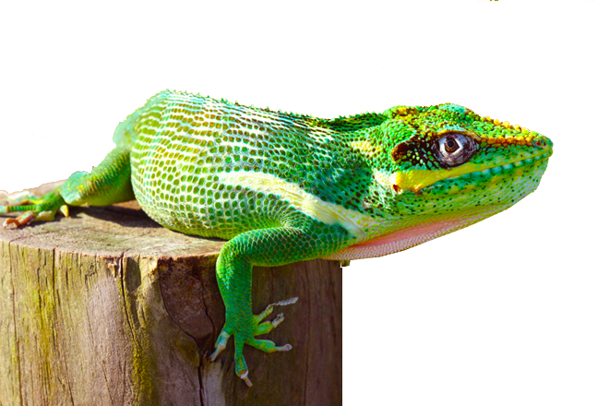

El Chipojo

The Chipojo is a lizard known as Cuban Knight Anole. It is the biggest of the Anole family reaching up to two feet. It’s native of Cuba and has been introduced into South Florida mainly around Miami. They can’t live further north. When the Floridian winter freezes they drop semi-consciously from tree canopies. It has a bonny head resembling a chess knight hence the name.

There are three striking characteristics of a chipojo:

|  |  |  |
| --- | --- | --- |
|  |  |  |
| When it’s healthy, it has a bright green color | It alerts intruders with a large red dewlap | and it feeds on any kind of bugs |

What else is green when healthy, alerts with a red flag and catches bugs? You guessed it!! Welcome to chipojos.com the revolutionary green acceptance test framework.

Stay tuned for more …

